Foreword

This document is aimed to provide instructions and helps to developers of Project-Seppia.

Date: **2016.08.27**

# Team

## Team Composition

|  |  |
| --- | --- |
| **Name** | **Job** |
| *Yangyang Liu* | *Android* |
| *David(Tianjin) Xu* | *Server, Backend* |
| *Qi Zhang* | *Android* |
| *Marc Müller* | *Web* |
| *Guangde Zhang* | *Android* |
| *Lance* | *Server, Backend* |
| *Orange* | *Android* |
| *Siyun Shen* | *UI, Logo, Icon Design* |

# Objectives

# Phases

## Phase I

### Target

The target of Phase I is to finish the basic functions of our Android and Web end programs.

### Details

Android: Finish layout design of Login-, Register-, Search- and Profile-Page and test functionality on Android-Studio emulator or real Android devices.

Web: Android equivalent version.

### Page-Level

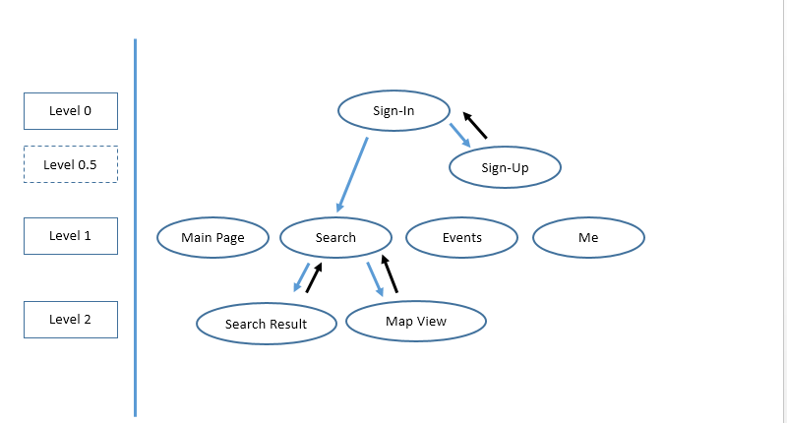

Black Arrow means back button.

Blue Arrow means advance to next level.

### Pages

#### Sign-In

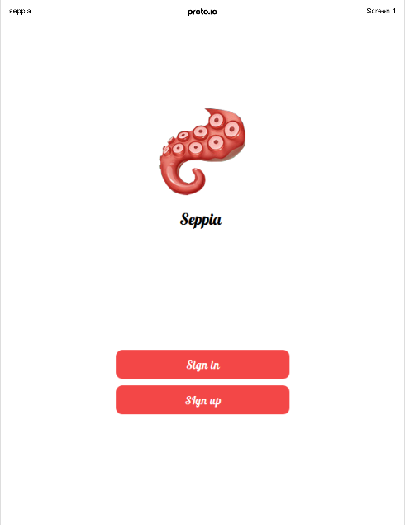

2 Buttons: Sign-In, Sign-Up

Navigation: Sign in button link to Page Search, Sign up button link to Page Sign-Up

Logo is assigned to Shen, will be done in 20160828.

#### Sign-Up

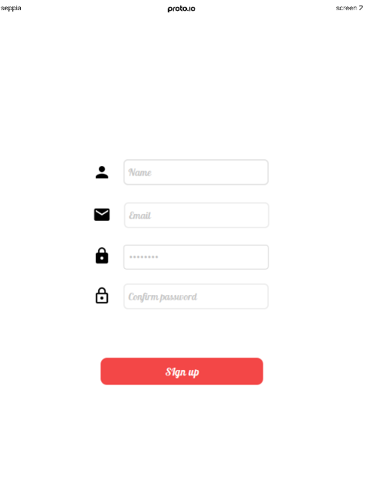

Confirm Password

Password, 2 rules: at least 8 digits, must have letters and numbers.

Email address

Name, that’s what will show up later

Button: Sign Up, Back

Navigations: Back Button link to page Sign-In

Functions: Sign-In Button will create a User-Account, with the information above.

#### Search

Standard Status Bar

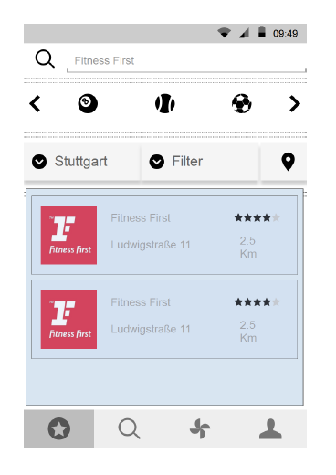

Thumbnail

Facility name

Facility address

Ratings

Distance to users current location

Row 4

Row 2

Row 3

Row 1

Me

Search

Search

Main Page

Search Bar, user should be able to search after specific facility name

Row 1: Search Bar, user can search after facility name, after pressing enter or pressing the “Search Icon” the search request is sent to Web Service.

Row 2: Set current sport type, only 1 sport type can be selected currently. The selected sport type should be placed in the center of the 3 sports icon and the background of this selected sport type should be grey.

Row 3: First: drop down box of cities, the default city should be based on user current location. After user clicked on drop down, a list of cities should be shown. These cities should be sorted after alphabetic order.

Second: drop down box of **sequence** type.(I have made a mistake here, instead of filter it should be **Sequence**/**排序**) The default should be based on location which means the nearest facility should be on the top of the list. All filter type include: a. location b. cost c. ratings

Third: Open google maps and show users’ current location and all the facilities in 20 km radius.

Row 4: Scroll View, shows the information about facilities. User should be able to scroll up/down to see further search result.

# Rules About Github

* Please double check the material you are gonna upload, all docs, codes, comments and other project related materials should be in English.